1. **How to compare two JSON have the same properties without order?**

var obj1 = { name: "Person 1", age:5 };

var obj2 = { age:5, name: "Person 1" };

var flag=true;

if(Object.keys(obj1).length==Object.keys(obj2).length){

    for(key in obj1) {

        if(obj1[key] == obj2[key]) {

            continue;

        }

        else {

            flag=false;

            break;

        }

    }

}

else {

    flag=false;

}

console.log(`is object equal ${flag}`);

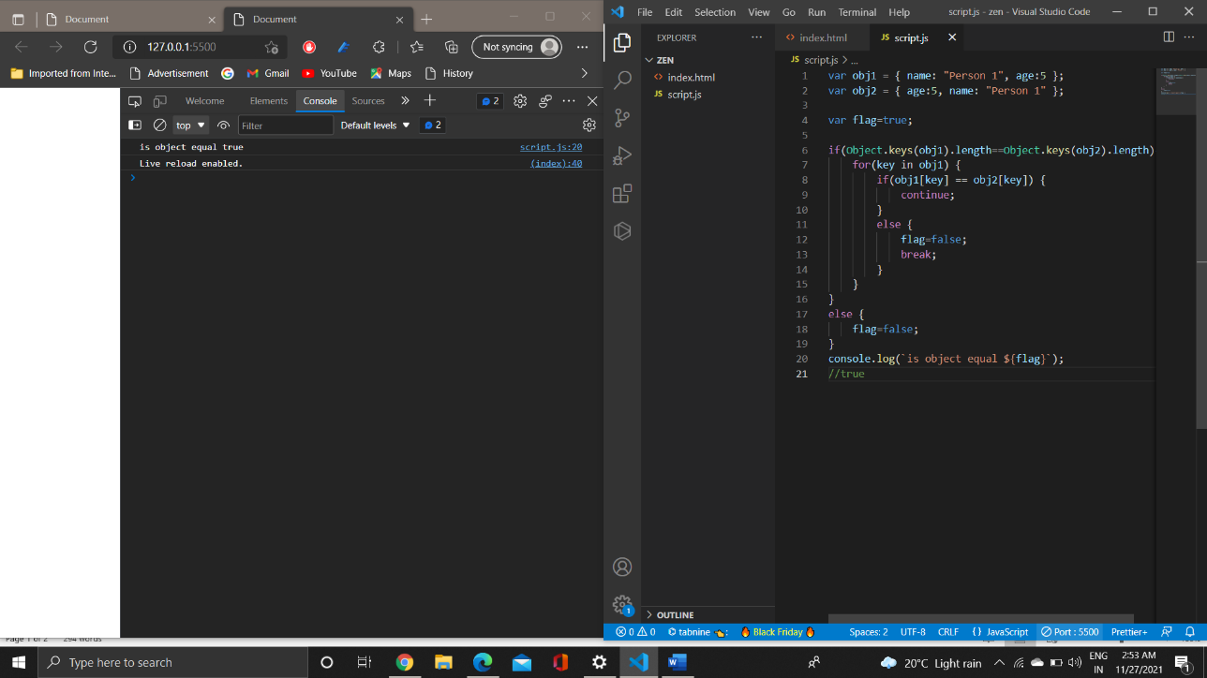

1. **Use the rest countries API url ->** [**https://restcountries.eu/rest/v2/all**](https://restcountries.eu/rest/v2/all) **and display all the country flags in console**

var xhr = new XMLHttpRequest();

xhr.open("Get","https://raw.githubusercontent.com/rvsp/restcountries-json-data/master/res-countries.json");

xhr.onload = function ()

{

 if(xhr.status>=200 && xhr.status<300)

  {

    var data = JSON.parse(this.responseText);

    for(i=0;i<data.length;i++)

    {

    console.log(data[i].flag);

    }

  }

  else

  {

    console.log("request failed")

  }

};

 xhr.send();

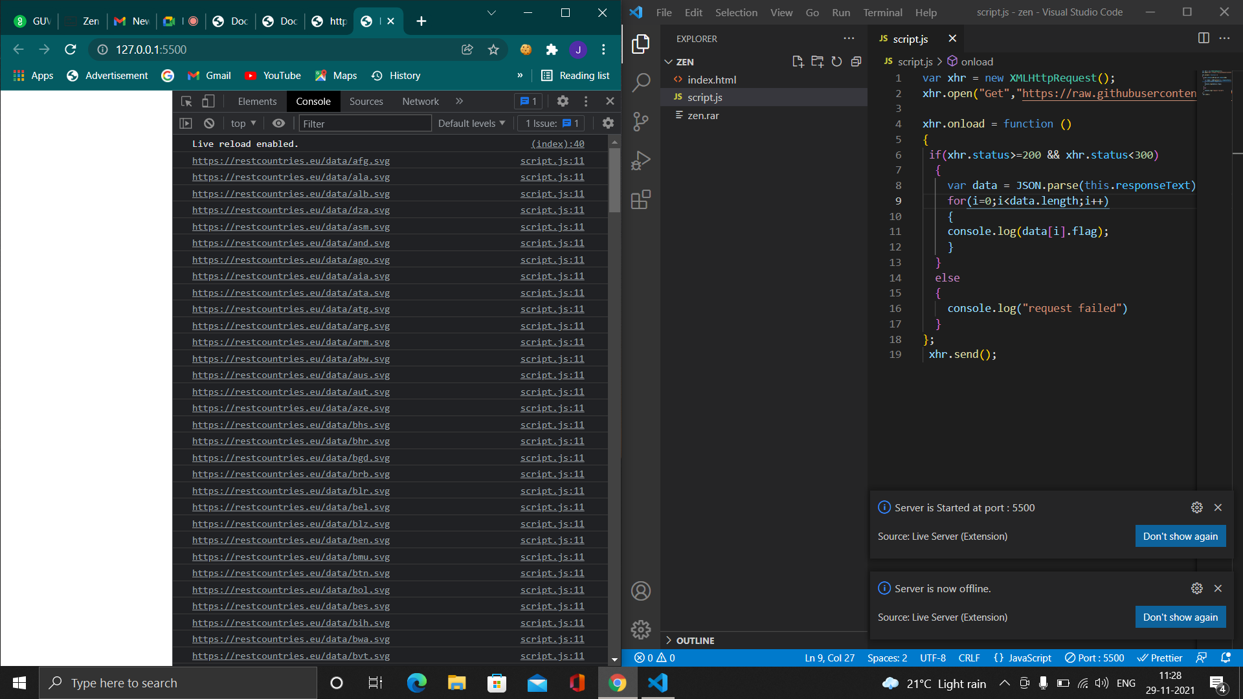

1. **Use the same rest countries and print all countries name, region, sub region and population**

var xhr = new XMLHttpRequest();

xhr.open("Get","https://raw.githubusercontent.com/rvsp/restcountries-json-data/master/res-countries.json");

xhr.onload = function ()

{

 if(xhr.status>=200 && xhr.status<300)

  {

    var data = JSON.parse(this.responseText);

    for(i=0;i<data.length;i++)

    {

    console.log(data[i].name);

    console.log(data[i].region);

    console.log(data[i].subregion);

    console.log(data[i].population);

    }

  }

  else

  {

    console.log("request failed")

  }

};

 xhr.send();

